**Software Design Methodology**

Assignment No: 1

**Project Statement of Work**

****

|  |  |  |
| --- | --- | --- |
| Project Group Information (**TY-25**) | | |
| Roll. No. | Gr. No. | Name |
| 63 | 11920122 | Vaishnavi kulkarni |
| 22 | 11810820 | Shreya Hirapurkar |
| 58 | 11810499 | Vinayak Kokane |
| 60 | 11810970 | Dhanraj Kore |

**Approved By:**

**Academic Year: 2020-21 Semester: II**

**Table of Contents**

|  |  |  |
| --- | --- | --- |
| **Sr. No.** | **Title** | **Page** |
| 1 | Introduction/Background | **4** |
| 2 | Purpose | **4** |
| 3 | Work Location | **5** |
| 4 | Tasks | **5** |
| 5 | Implementation | **6** |
| 6 | Milestone/Scheduling | **7** |
| 7 | Deliverable | **7** |
| 8 | Testing | **8** |
| 9 | Success Report | **8** |
| 10 | Scope of work | **9** |
| 11 | Future Scope | **11** |
| 12 | Closure of the Project | **11** |

## 

### Project Title

**ONLINE FOOD ORDER SYSTEM**

## Introduction/Background

This project will allow hotels and restaurants to increase scope of business by reducing the labor cost involved. The system also allows to quickly and easily manage an online menu which customers can browse and use to place orders with just a few clicks. Restaurant employees then use these orders through an easy to navigate graphical interface for efficient processing. Online ordering system that we are proposing here greatly simplifies the ordering process for both the customer and the restaurant. System presents an interactive and up-to-date menu with all available options in an easy to use manner. Customers can choose one or more items to place an order which will land in the Cart. Customers can view all the order details in the cart before checking out. At the end, the customer gets order confirmation details. Once the order is placed it is entered in the database and retrieved in pretty much real time.

## Purpose

This Case study looks at the problem of setting up a fast food restaurant. In existing system there are few problems:

* For placing any orders customers have to visit hotels or restaurants to know about food items and then place orders and pay. In this method time and manual work is required.
* While placing an order over the phone, the customer lacks the physical copy of the menu item, lack of visual confirmation that the order was placed correctly.
* Every restaurant needs certain employees to take the order over phone or in-person, to offer a rich dining experience and process the payment. In today’s market, labor rates are increasing day by day making it difficult to find employees when needed.

Hence, to solve this issue, what I propose is an “Online Food Order System, originally designed for small scale business like College Cafeterias, Fast Food restaurant or Take-Out, but this system is just as applicable in any food delivery industry.

The main advantage of my system is that it greatly simplifies the ordering process for both the customer and the restaurant and also greatly lightens the load on the restaurant’s end, as the entire process of taking orders is automated.

## Work Location : Work from home - VIT,Pune

* The location of the work related to this project will be done remotely.

### Tasks :

Implementing :

1. User Module
2. Menu management module
3. Order Retrieval Module

For all 3 Modules

* Task 1 : Design Front End & Back-end Flow.
* Task 2 : Determine back-end flow according to design.
* Task 3 : Integrating with the front-end & fixing the bugs.

## 

## Implementation

1. User Module: This module basically provides the functionalities for customer to order. So to become the user of system user has to do following things.

Create an account

Login into account

There are the functionalities provided to customers:

Navigate to restaurant

Select the item from menu

Add the current item to current order.

Place an order

View order placed.

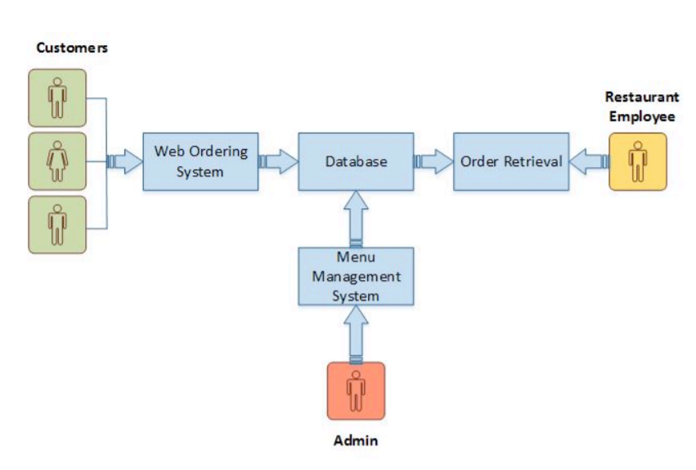

1. Menu Management module: This module is for Administrator staff to manage the menu details of restaurant.

The managerial staff able to see the Users /customers in their system and manage the menu displayed to user.They can :

* ADD/INSERT/DELETE the food items to menu.
* UPDATE the price of food according to category.
* ADD/ DELETE/ UPDATE the category of food.
* UPDATE the images and videos on sites

1. Order Retrieval module: It is designed to be used only by restaurant employees, and provides the following functions:

* Retrieve new orders from database
* Display the orders

### Milestone for Above Tasks:

* Task 1 : 2 weeks
* Task 2 : 1 week
* Task 3 : 2-3 weeks

Final Testing: At-most 1 week

This system will allow hotels and restaurants to increase scope of business by reducing the labor cost involved

## Deliverable

* Project synopsis
* Work statement
* Implementation Document
* Project Outcome
  + This system will provide customers for a way to place an order at a restaurant over the internet
  + This system will allow hotels and restaurants to increase scope of business by reducing the labor cost involved.

Expected time-span of completion : 5-6 weeks.

## Testing

* Step 1: Functional Testing.
* Step 2: Usability Testing
* Step 3: Interface Testing.
* Step 4: Compatibility Testing
* Step 5: Performance Testing
* Step 6: Security Testing.

People Involved in testing:

1. Client
2. UI/UX designer
3. Developer, Database Designer
4. Security head

## Success

Project will be completed successfully.

## Scope of Work

## All users of the system, are provided with below menu options: Home, Menu, My Cart, User Account,   About Us and Contact

## Home:

## It allows user to see the menu option which includes food items, images and videos as well as the option selecting an item to place an order.

## Menu:

## Here we have provided the dropdown option for menu. It allows user to see the food items based on category of the food.

## My Cart:

## Allows users to see details of the items placed in cart. Details include Item #, Product Name, Product Image, Product Description, Quantity, Unit Price, Total per item and final Total of the order. It also allows ‘Update’ and ‘Delete’ an item using single button click. User can then use a ‘Proceed to checkout’ button to proceed further.

## IMG_256

## Payments :

## After clicking on check out button, if user is not sign in/sign up then it will redirect for sign in/ sign up else it will directly sow “payment Information” form. After this used has to fill the payment related details into that form and ‘save’ all the details.

## After this user is able to “Review Order” which includes the payment details along with order details.

## Once the order is placed, user is able to see the whether order is successful/failure message.

## User Account:

## In this section, the user is able to see menu which will display the user orders with sign in and sign out option.

## Future Scope

* Restaurant Locator: Allow to find and choose a nearby restaurant
* Payment Options: we can add different payment options such as PayPal, Cash, Gift Cards etc. Allow to save payment details for future use.
* Order Cancellation
* Order Ready notification: Send an Order Ready notification to the customer
* Allow to process an order as a Guest
* Delivery Options: Add delivery option

## Closure of the project

* All the requirements are fulfilled.
* All the features are successfully implemented.
* Website has been thoroughly tested for bugs/errors.
* All deliverable’s of the project are completed and delivered to the customer.